UNIT I

* Hours Blockchain 101:
  + Distributed systems
  + History of blockchain,
  + Introduction to blockchain
  + Types of blockchain
  + CAP theorem and blockchain
  + Benefits and limitations of blockchain.

**Distributed systems:**

* Understanding distributed systems is essential in order to understand blockchain because basically blockchain at its core is a distributed system. More precisely it is a decentralized distributed system.
* Distributed systems are a computing paradigm whereby two or more nodes work with each other in a coordinated fashion in order to achieve a common outcome and it's modeled in such a way that end users see it as a single logical platform.
* A node can be defined as an individual player in a distributed system. All nodes are capable of sending and receiving messages to and from each other.
* Nodes can be honest, faulty, or malicious and have their own memory and processor. A node that can exhibit arbitrary behaviour is also known as a Byzantine node.
* This arbitrary behaviour can be intentionally malicious, which is detrimental to the operation of the network. Generally, any unexpected behaviour of a node on the network can be categorized as Byzantine.
* His term arbitrarily encompasses any behaviour that is unexpected or malicious:
* The main challenge in distributed system design is coordination between nodes and fault tolerance. Even if some of the nodes become faulty or network links break, the distributed system should tolerate this and should continue to work flawlessly in order to achieve the desired result.
* This has been an area of active research for many years and several algorithms and mechanisms has been proposed to overcome these issues.
* Distributed systems are so challenging to design that a theorem known as the CAP theorem has been proved and states that a distributed system cannot have all much-desired properties simultaneously. In the next section, a basic introduction to the CAP theorem will be provided.

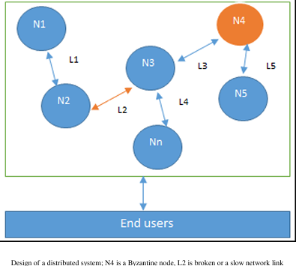

A distributed system is a computing paradigm where multiple independent nodes work together to achieve a common goal, presenting themselves to users as a single coherent system. Here are the key characteristics that distinguish distributed systems from centralized systems:

**Here are the key characteristics that distinguish distributed systems from centralized systems:**

**Multiple Nodes:** A distributed system consists of multiple nodes (computers or devices) that communicate and coordinate with each other to perform tasks.

**No Central Authority:** Unlike centralized systems, where a single entity controls the entire system, distributed systems operate without a central authority. Control and decision-making are spread across the nodes.

**Autonomy:** Each node in a distributed system operates independently and can make its own decisions. Nodes can fail or be added without affecting the overall system.

**Scalability:** Distributed systems can easily scale by adding more nodes to the network, allowing for increased capacity and performance without significant redesign.

**Fault Tolerance:** These systems are designed to continue functioning even when some nodes fail. Redundancy and replication are often employed to ensure reliability.

**Concurrency:** Multiple nodes can process tasks simultaneously, allowing for parallel processing and improved performance.

**Communication**: Nodes in a distributed system communicate over a network, often using message-passing protocols. This communication can introduce latency and requires mechanisms to handle synchronization and consistency.

**Data Distribution**: Data is often distributed across multiple nodes rather than being stored in a single location. This can enhance performance and availability but also complicates data management.

**Transparency**: A well-designed distributed system aims to provide transparency to users, making the distribution of resources and processes invisible, so users perceive the system as a single entity.

**Heterogeneity**: Distributed systems can consist of different types of nodes (e.g., different hardware, operating systems, and network protocols), allowing for a diverse range of components to work together.

**Resource Sharing:** Nodes in a distributed system can share resources (such as processing power, storage, and data) with one another, enhancing overall efficiency.

**Security Challenges:** Distributed systems face unique security challenges, such as ensuring secure communication between nodes and protecting against malicious nodes, which are less of a concern in centralized systems.

**History of Blockchain**

Blockchain technology was introduced with the invention of Bitcoin in 2008, followed by its practical implementation in 2009. While a full chapter on Bitcoin will delve deeper into its details, it’s necessary to touch on Bitcoin briefly here, as the history of blockchain is incomplete without it.

The concept of electronic cash, or digital currency, predates Bitcoin. Since the 1980s, various e-cash protocols, inspired by a model proposed by David Chaum, have existed.

The historical development of blockchain technology has been characterized by several key milestones that have significantly influenced its evolution. Here’s a detailed overview of these milestones:

**1. Early Concepts of Digital Cash (1980s)**

* **David Chaum's E-Cash**: The idea of digital cash emerged with David Chaum's work on e-cash protocols, introducing concepts like **blind signatures** and **secret sharing**. These concepts aimed to address issues of accountability and anonymity in digital transactions.

**2. Hash cash (1997)**

* **Adam Back's Proof-of-Work**: Hashcash was developed as a proof-of-work system to combat email spam. This foundational concept laid the groundwork for the mining process in blockchain technology, where computational work is required to validate transactions.

**3. B-Money (1998)**

* **Wei Dai's Proposal**: B-money was proposed as an anonymous, distributed electronic cash system. Though it was never implemented, it introduced ideas about decentralized control and the use of a distributed ledger.

**4. Bit Gold (1998)**

* **Nick Szabo's Bit Gold**: Bit Gold proposed a decentralized digital currency that required proof of work to create currency units. Szabo introduced the concept of a chain of blocks, which later evolved into the blockchain structure we know today.

**5. Introduction of Bitcoin (2008)**

* **Satoshi Nakamoto's White Paper**: The publication of the white paper titled **"Bitcoin: A Peer-to-Peer Electronic Cash System"** marked a pivotal moment in blockchain history. It outlined the principles of a decentralized digital currency and introduced the concept of a blockchain as a public ledger.

**6. Launch of Bitcoin (2009)**

* **Genesis Block**: Bitcoin was launched in January 2009, with Nakamoto mining the first block, known as the **"genesis block."** This event marked the practical implementation of blockchain technology, allowing users to send and receive Bitcoin without a central authority.

**7. Emergence of Alternative Cryptocurrencies (2011)**

* **Rise of Altcoins**: Following Bitcoin's success, several alternative cryptocurrencies (altcoins) were created, including **Litecoin** and **Namecoin**. These projects explored variations of blockchain technology and consensus mechanisms, leading to increased experimentation in the space.

**8. Introduction of Smart Contracts (2013)**

* **Vitalik Buterin's Ethereum**: Vitalik Buterin proposed **Ethereum**, a platform that expanded blockchain capabilities beyond simple transactions to include **smart contracts**—self-executing contracts with terms directly written into code. Ethereum was officially launched in 2015.

**9. Initial Coin Offerings (ICOs) (2017)**

* **Boom of Token Sales**: The ICO boom allowed startups to raise funds by issuing tokens on blockchain platforms. This fundraising method gained immense popularity but also attracted regulatory scrutiny due to cases of fraud and scams.

**10. Mainstream Adoption and Institutional Interest (2018-2020)**

* **Corporate Exploration**: Major corporations and financial institutions began exploring blockchain for various applications, including supply chain management, identity verification, and cross-border payments. Initiatives like **Hyperledger** and **R3 Corda** emerged to facilitate enterprise blockchain solutions.

**11. Decentralized Finance (DeFi) (2020)**

* **Disruption of Traditional Finance**: The DeFi movement gained momentum, enabling users to engage in financial services (lending, borrowing, trading) without intermediaries, showcasing blockchain's potential to disrupt traditional finance.

**12. Non-Fungible Tokens (NFTs) (2021)**

* **Rise of Unique Digital Assets**: NFTs, which represent ownership of unique digital items or content, highlighted blockchain's versatility beyond currency. This trend gained significant attention, especially in the art and entertainment sectors.

**13. Regulatory Developments (2021-Present)**

* **Frameworks for Governance**: As blockchain technology and cryptocurrencies gained popularity, governments and regulatory bodies began establishing frameworks to govern their use, addressing concerns related to security, fraud, and consumer protection.

**Electronic Cash**

To understand blockchain technology, it’s important to grasp the idea of electronic cash, as Bitcoin—broadly representing cryptocurrencies—was its first successful application. Concepts from distributed systems, such as consensus algorithms, provided the foundation for Bitcoin’s Proof of Work (PoW) algorithm. Additionally, earlier electronic cash schemes laid the groundwork for Bitcoin and cryptocurrencies.

This section introduces electronic cash, along with various pre-existing concepts that contributed to Bitcoin’s development.

**The Concept of Electronic Cash**

Key issues in e-cash systems are accountability and anonymity. In 1984, David Chaum addressed these with two cryptographic innovations: blind signatures and secret sharing. Blind signatures allow signing a document without seeing its content, while secret sharing detects double spending of the same e-cash token. These concepts are discussed further in Chapter 3, *Cryptography and Technical Foundations*.

Following Chaum’s work, other protocols emerged, like the Chaum-Fiat-Naor (CFN) e-cash schemes, which introduced anonymity and double-spending detection. Brand’s e-cash improved on CFN by enhancing efficiency and introducing *security reduction*, a cryptographic technique to prove the security of an algorithm by comparing it to a hard problem.

In 1997, Adam Back introduced *hashcash*, a PoW system to combat email spam. It required users to compute a hash as proof of spending computational resources before sending an email. While computationally intensive, this was feasible for legitimate users but impractical for spammers needing to send thousands of emails. Hashcash is now widely recognized for its role in Bitcoin mining. The idea of computational puzzles, or *pricing functions*, was first introduced by Cynthia Dwork and Moni Naor in 1992 to prevent spam, with Back later refining it independently in 1997.

In 1998, Wei Dai introduced *b-money*, proposing a system for creating currency by solving computational puzzles like hashcash in a peer-to-peer network, with each node maintaining a list of transactions. In 2005, Nick Szabo proposed a similar idea, *BitGold*, and Hal Finney introduced the concept of cryptographic currency, combining ideas from b-money and hashcash puzzles, though it still relied on a trusted authority.

These early attempts faced issues, including a lack of clear solutions for resolving disagreements between nodes and reliance on trusted third parties and timestamping.

**Bitcoin and the First Implementation of Blockchain**

In 2009, Bitcoin was introduced as the first practical cryptocurrency, solving the problem of distributed consensus in a trustless network. It uses public key cryptography and hashcash as PoW to secure a decentralized digital currency. The key innovation was an ordered list of blocks containing transactions, secured by the PoW mechanism—a structure later recognized as blockchain. This concept is elaborated in Chapter 4, *Bitcoin*.

Looking at these technologies and their evolution, it’s clear that ideas from electronic cash schemes and distributed systems converged to create Bitcoin and what we now call blockchain.

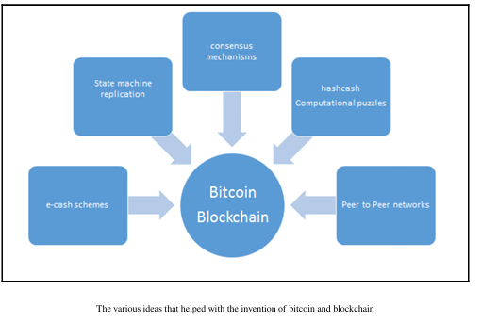

**Introduction to Blockchain**

There are various definitions of blockchain; its meaning can differ depending on the perspective taken. From a **business perspective**, blockchain can be defined as a platform for exchanging value through transactions without the need for a central trusted authority. Conversely, from a **technical perspective**, it can be viewed as a set of protocols that enable secure and efficient data exchange.

At its core, blockchain is a **peer-to-peer distributed ledger** that is:

* **Cryptographically secure**
* **Append-only** (new data can be added, but existing data cannot be altered)
* **Immutable** (extremely difficult to change)
* **Updateable only via consensus** or agreement among peers.

**Blockchain 101**

Blockchain can be thought of as a layer in a distributed peer-to-peer network operating on top of the Internet. This structure is analogous to how protocols such as SMTP, HTTP, or FTP run on top of TCP/IP.

From a business viewpoint, blockchain's ability to facilitate peer-to-peer transactions without central authority is revolutionary. Once understood, readers will appreciate the profound potential of blockchain technology, which enables decentralized consensus where no single entity controls the database.

**Key Components of Blockchain**

1. **Blocks**: A block is a collection of transactions bundled together to organize them logically. The size of a block varies depending on the blockchain's design. Each block includes a reference to a previous block, except for the **genesis block**, which is the first block hardcoded at the start of the blockchain.
2. **Genesis Block**: This is the initial block in a blockchain, hardcoded when the blockchain was initiated.
3. **Block Structure**: The typical structure of a block includes:
   * **Block Header**: Contains metadata about the block.
   * **Pointers to Previous Blocks**: Ensures the continuity of the blockchain.
   * **Timestamp**: Records when the block was created.
   * **Nonce**: A number used in mining to generate a valid block hash.
   * **Transaction Counter**: Indicates the number of transactions included.
   * **Transactions**: The actual data or transactions that the block contains.
   * **Other Attributes**: Additional details that may vary depending on the specific blockchain.

This foundational understanding of blockchain emphasizes its transformative potential, enabling secure and decentralized peer-to-peer exchanges. Specific blockchain technologies and their structures will be explored in greater detail later in the book.

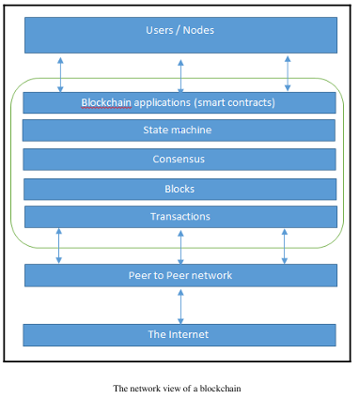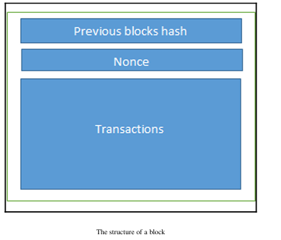

**Various Technical Definitions of Blockchains**

1. **Decentralized Consensus Mechanism**:  
   Blockchain serves as a decentralized consensus mechanism where all participating peers reach an agreement regarding the state of transactions. This consensus ensures that all nodes maintain a consistent view of the transaction history without needing a central authority.
2. **Distributed Shared Ledger**:  
   Blockchain can be viewed as a distributed shared ledger of transactions. In this framework, transactions are ordered and grouped into blocks. Unlike traditional systems, where each organization maintains its own private database, a distributed ledger can function as a single source of truth for all member organizations using the blockchain, promoting transparency and trust.
3. **Data Structure**:  
   At a fundamental level, blockchain is a data structure, often visualized as a linked list. However, instead of conventional pointers, it employs **hash pointers** to link blocks. Hash pointers not only reference the location of the previous block but also incorporate the hash of that block, enhancing security and integrity by making it difficult to alter any part of the blockchain without detection.

**Visualization of a Generic Blockchain Structure**

The structure of a generic blockchain can be visualized as follows:

[ Block 1 ] --> [ Block 2 ] --> [ Block 3 ] --> ... --> [ Block N ]

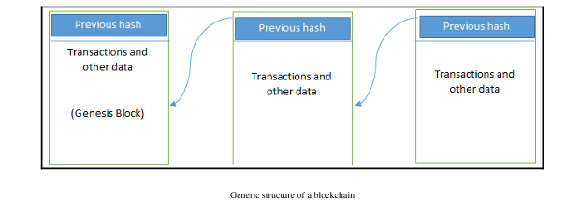

* Each block contains a list of transactions, a timestamp, a nonce, and a hash of the previous block, forming a secure and tamper-resistant chain.

This diagram highlights the sequential and interconnected nature of blockchain, emphasizing its role as both a consensus mechanism and a shared ledger. Each block's reliance on the previous block reinforces the integrity and security of the entire blockchain structure.

**Generic Elements of a Blockchain**

In this section, we present the fundamental elements that constitute a blockchain. Specific elements will be discussed in the context of particular blockchains, such as Ethereum, in later chapters.

**1. Addresses**

Addresses serve as unique identifiers in transactions on the blockchain, representing senders and recipients. Typically derived from public keys, these addresses are unique to each transaction. While users can reuse addresses, it's recommended to generate a new address for each transaction to enhance privacy. This practice helps avoid linking transactions to a single owner, thus minimizing identification risks.

**2. Transaction**

A transaction is the basic unit of a blockchain, representing a transfer of value from one address to another.

**3. Block**

A block is composed of multiple transactions along with additional elements, including the previous block's hash (hash pointer), a timestamp, and a nonce.

**4. Peer-to-Peer Network**

A peer-to-peer (P2P) network enables all participants (peers) to communicate and exchange messages with one another without intermediaries.

**5. Scripting or Programming Language**

This element allows various operations on transactions. Transaction scripts are predefined commands for nodes to facilitate the transfer of tokens and execute other functions. A Turing-complete programming language is desirable, though its security remains a critical area of research.

**6. Virtual Machine**

A virtual machine extends transaction scripts by allowing Turing-complete code (such as smart contracts) to be executed on the blockchain. Various blockchains, like Ethereum and Chain, utilize virtual machines, although not all blockchains provide this capability.

**7. State Machine**

A blockchain can be viewed as a state transition mechanism, where the state evolves from its initial form to subsequent forms based on the execution and validation of transactions by nodes.

**8. Nodes**

Nodes perform various functions based on their roles within the blockchain network. They can propose and validate transactions, engage in mining to achieve consensus, or provide lightweight verification. Different node roles may exist, depending on the specific blockchain's architecture.

**9. Smart Contracts**

Smart contracts are programs that run on the blockchain, encapsulating business logic to be executed when predefined conditions are met. While not all blockchains support smart contracts, their inclusion is increasingly sought after for added flexibility and power in blockchain applications.

**Features of a Blockchain**

1. **Distributed Consensus**:  
   This is the foundation of a blockchain, enabling all participants to agree on a single version of truth without relying on a central authority.
2. **Transaction Verification**:  
   Transactions are verified according to predetermined rules, ensuring that only valid transactions are included in a block.
3. **Platforms for Smart Contracts**:  
   Blockchains can serve as platforms for executing business logic through smart contracts, although this feature is not universally available.
4. **Transferring Value Between Peers**:  
   Blockchains facilitate value transfer through tokens, which act as carriers of value.
5. **Generating Cryptocurrency**:  
   Depending on the blockchain, cryptocurrency may be generated as an incentive for miners who validate transactions and secure the network.
6. **Smart Property**:  
   Blockchain enables linking digital or physical assets irrevocably, ensuring ownership and preventing double spending—an essential feature for digital rights management and electronic cash systems.
7. **Provider of Security**:  
   Blockchain employs proven cryptographic technologies to ensure data integrity and availability. However, confidentiality may be compromised for transparency, which is a significant barrier for financial institutions.
8. **Immutability**:  
   Records added to the blockchain are considered immutable. Altering previous blocks would require substantial computing resources, making it practically impossible.
9. **Uniqueness**:  
   Each transaction is unique, ensuring that it has not been previously spent, which is crucial for avoiding double spending in cryptocurrencies.
10. **SmartContracts**:  
    As autonomous programs, smart contracts allow for flexibility and programmability, encapsulating business logic to execute specific functions under certain conditions. This feature greatly enhances user control and adaptability in blockchain applications.

**CAP Theorem**

The **CAP theorem**, also known as **Brewer's theorem**, was originally introduced as a conjecture by Eric Brewer in 1998 and was later proven as a theorem by Seth Gilbert and Nancy Lynch in 2002. The theorem states that any distributed system cannot simultaneously achieve:

1. **Consistency**: All nodes in a distributed system have a single latest copy of data.
2. **Availability**: The system is operational, accessible for use, and is able to respond to incoming requests without failures.
3. **Partition Tolerance**: The system continues to operate correctly even if a group of nodes fails.

It has been proven that a distributed system cannot have all three of the aforementioned properties at the same time. This presents a paradox, especially considering how blockchain technology seems to achieve all these properties—though this will be discussed later in the chapter within the context of blockchain.

To achieve fault tolerance, **replication** is commonly used. This method involves maintaining multiple copies of data across different nodes. Consistency is ensured through **consensus algorithms**, which guarantee that all nodes maintain the same copy of data, a concept referred to as **state machine replication**. In essence, blockchain operates as a form of state machine replication.

There are generally two types of faults that a node can experience:

* **Crash Faults**: Where a faulty node simply crashes.
* **Byzantine Faults**: Where a faulty node exhibits malicious or inconsistent behavior. This latter type is particularly challenging, as it can lead to confusion due to misleading information.

**Byzantine Generals Problem**

Before delving into consensus in distributed systems, it is important to acknowledge the historical events that led to the development of effective consensus mechanisms.

In September 1962, Paul Baran introduced the concept of **cryptographic signatures** in his paper *On Distributed Communications Networks*, which was also the first time the idea of decentralized networks was introduced. In 1982, Lamport et al. proposed a thought experiment known as the **Byzantine Generals Problem**. In this scenario, a group of army generals, each commanding different segments of the Byzantine army, must agree to attack or retreat from a city. The only means of communication available to them is through messengers. They need to agree to launch an attack simultaneously to succeed. The challenge arises from the possibility that one or more generals might be traitors, sending misleading messages.

In the context of distributed systems, the generals represent nodes, the traitors are analogous to **Byzantine (malicious) nodes**, and the messengers are channels of communication among the generals.

This problem was effectively addressed in 1999 by Castro and Liskov, who introduced the **Practical Byzantine Fault Tolerance (PBFT)** algorithm. The first practical implementation of a consensus mechanism arose in 2009 with the advent of Bitcoin, which employed the **Proof of Work (PoW)** algorithm.

**Consensus**

**Consensus** refers to the process of achieving agreement among distrusting nodes regarding the final state of data. While reaching an agreement between two nodes (as in client-server systems) can be straightforward, it becomes significantly more complex when multiple nodes in a distributed system must agree on a single value. This concept is known as **distributed consensus**.

**Consensus Mechanisms**

A **consensus mechanism** comprises a set of steps that most or all nodes follow to agree on a proposed state or value. This concept has been extensively researched for over three decades by computer scientists in both industry and academia. The rise of Bitcoin and blockchain technology has further highlighted the importance of consensus mechanisms.

**Requirements for Consensus Mechanisms**

To yield the desired outcomes, several requirements must be met by consensus mechanisms:

1. **Agreement**: All honest nodes must decide on the same value.
2. **Termination**: All honest nodes must complete the consensus process and eventually reach a decision.
3. **Validity**: The agreed-upon value must correspond to an initial value proposed by at least one honest node.
4. **Fault Tolerance**: The consensus algorithm must function correctly in the presence of faulty or malicious nodes (Byzantine nodes).
5. **Integrity**: No node should make a decision more than once; decisions are made only once per consensus cycle.

**Types of Consensus Mechanisms**

Several common types of consensus mechanisms include:

1. **Byzantine Fault Tolerance-Based**: This approach does not involve compute-intensive operations like partial hash inversion and relies on nodes publishing signed messages. An agreement is reached once a certain number of messages are received.
2. **Leader-Based Consensus Mechanisms**: In this model, nodes compete in a leader-election process. The winning node proposes a final value.
   * **Paxos**: Introduced by Leslie Lamport in 1989, this protocol assigns roles such as Proposer, Acceptor, and Learner to nodes. Consensus is achieved through agreement among a majority of nodes, even in the presence of faults.
   * **RAFT**: This alternative to Paxos assigns one of three states (Follower, Candidate, Leader) to nodes. A Leader is elected when a candidate node receives sufficient votes. All changes must go through the Leader, who commits proposed changes once they are replicated across a majority of follower nodes.

**Types of Blockchains**

* **Public Blockchains:** Open for anyone to participate and are maintained by users.
* **Private Blockchains:** Accessible only to a consortium of trusted participants.
* **Semi-Private Blockchains:** Combine private and public elements, with controlled access.
* **Sidechains:** Enable the transfer of tokens between blockchains.
* **Permissioned Ledgers:** Participants are known and trusted, eliminating the need for certain consensus mechanisms.
* **Distributed and Shared Ledgers:** Variations that can be public or private, focusing on data distribution.
* **Fully Private Blockchains:** Used in specific scenarios, though they stray from core blockchain principles.
* **Tokenized and Token less Blockchains:** Differentiated based on the presence of cryptocurrencies as value transfers.

**Comparison of Public, Private, and Consortium Blockchains**

**Public Blockchains**

**Definition**: Public blockchains are open to anyone who wishes to participate. They are decentralized and do not require permission to join the network.

**Characteristics**:

* **Open Access**: Anyone can join the network, validate transactions, and participate in the consensus process.
* **Decentralization**: No single entity controls the network; it is maintained by a distributed group of participants.
* **Transparency**: All transactions are visible to anyone, promoting trust and accountability.
* **Security**: High level of security due to the large number of participants and the consensus mechanisms used (e.g., Proof of Work).

**Examples**:

* **Bitcoin**: The first and most well-known cryptocurrency, operating on a public blockchain.
* **Ethereum**: A platform that enables the creation of decentralized applications (dApps) and smart contracts on its public blockchain.

**Private Blockchains**

**Definition**: Private blockchains are restricted to a specific group of participants. Access is controlled, and only authorized users can join the network.

**Characteristics**:

* **Restricted Access**: Only selected participants can access the network and validate transactions.
* **Centralized Control**: A single organization or a consortium of organizations typically governs the network.
* **Privacy**: Transaction details may be hidden from non-participants, providing confidentiality.
* **Efficiency**: Faster transaction processing and lower energy consumption compared to public blockchains due to fewer participants.

**Examples**:

* **Hyperledger Fabric**: An open-source framework for building private blockchains, often used in enterprise settings.
* **R3 Corda**: A blockchain platform designed for financial institutions, allowing them to transact directly with each other while maintaining privacy.

**Consortium Blockchains**

**Definition**: Consortium blockchains are governed by a group of organizations rather than a single entity. They are semi-decentralized and allow multiple organizations to collaborate.

**Characteristics**:

* **Controlled Access**: Participation is limited to a predefined group of organizations, which can be either public or private.
* **Shared Governance**: Decisions regarding the network are made collectively by the consortium members.
* **Balance of Transparency and Privacy**: While some transaction details may be visible to all members, others can remain private, depending on the consortium's rules.
* **Collaboration**: Ideal for industries where multiple organizations need to work together while maintaining some level of privacy.

**Examples**:

* **R3 Corda**: While primarily a private blockchain, it can also function as a consortium blockchain, allowing multiple financial institutions to collaborate.
* **Hyperledger Fabric**: Can be used to create consortium blockchains where multiple organizations share a common ledger while maintaining control over their data.

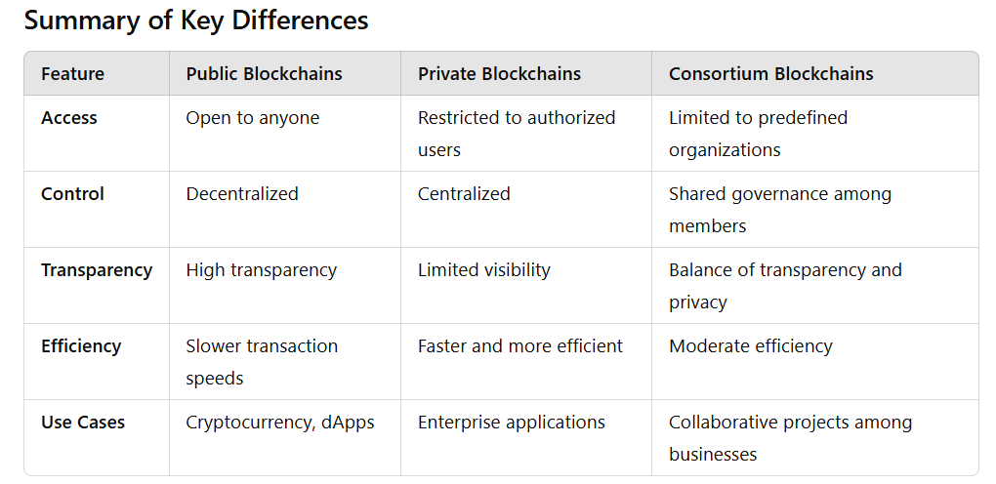

**Applications of Blockchain Technology**

* **Sectors Impacted:** Blockchain has applications across various sectors, including finance, government, media, law, and arts. The potential of blockchain is recognized by almost all industries, leading to exploration of its benefits.
* **Use Cases:** Chapter 9 will delve into specific use cases within different industries.

**How Blockchains Accumulate Blocks**

1. **Transaction Initiation:** A node begins a transaction by signing it with a private key.
2. **Propagation and Validation:** The transaction is spread through a gossip protocol to peers for validation. Typically, multiple nodes must validate the transaction.
3. **Block Inclusion:** Once validated, the transaction is included in a block and propagated across the network, marking the transaction as confirmed.
4. **Blockchain Linking:** The new block links to the previous block through a cryptographic hash pointer, confirming both the transaction and the block.
5. **Reconfirmations:** Transactions are reconfirmed as new blocks are created, with Bitcoin generally requiring six confirmations for finality.

**Tiers of Blockchain Technology**

* **Blockchain 1.0:** Focused on cryptocurrencies (e.g., Bitcoin).
* **Blockchain 2.0:** Introduces financial services and smart contracts, expanding beyond mere currency.
* **Blockchain 3.0:** Used in various industries like government and healthcare, addressing broader applications.
* **Generation X (Blockchain X):** Envisions a public blockchain service that allows for general-purpose applications and decision-making through intelligent agents.

**Consensus Mechanisms in Blockchain**

* **Definition:** Consensus ensures agreement on the blockchain's state among all network peers.
* **Types of Consensuses:**
  + **Proof of Work (PoW):** Requires computational effort for transaction validation (used in Bitcoin).
  + **Proof of Stake (PoS):** Based on user investment in the network.
  + **Delegated Proof of Stake (DPoS):** Allows stakeholders to delegate validation.
  + **Proof of Elapsed Time (PoET):** Introduced by Intel for leader election.
  + **Others:** Including Federated Consensus, Practical Byzantine Fault Tolerance, and various reputation-based mechanisms.

**Benefits of Blockchain**

1. **Decentralization:** Reduces reliance on third parties.
2. **Transparency and Trust:** Provides a transparent and trustworthy system.
3. **Immutability:** Difficult to alter data once recorded.
4. **High Availability:** Network remains operational even with node failures.
5. **Security:** Cryptographic security ensures data integrity.
6. **Simplification:** Reduces complexity in data management.
7. **Faster Dealings:** Accelerates transactions in industries like finance.
8. **Cost Savings:** Eliminates the need for intermediaries, reducing costs.

**Challenges and Limitations**

* **Scalability:** Issues related to transaction throughput.
* **Adaptability:** The ability to evolve with changing needs.
* **Regulation:** Navigating legal frameworks.
* **Immature Technology:** The ongoing development phase of blockchain.
* **Privacy:** Ensuring user privacy while maintaining transparency.